**What are Lipids?**

**Lipids**are group of heterogeneous organic compounds which are soluble in non-polar solvents. Lipids naturally occur in most plants, animals, and microorganisms. They include a variety of compounds such as fatty acids, phospholipids, sterols, sphingolipids, terpenes, and others. Structurally, they are esters or amides of fatty acids. These molecules can be soluble in non-polar solvents but can’t be soluble in water.

Beyond their structural roles, lipids function as insulators, assisting in the maintenance of body temperature, and steroid hormones play a vital role in regulating various physiological processes. In the diet, lipids provide essential fatty acids and facilitate the absorption of fat-soluble vitamins.

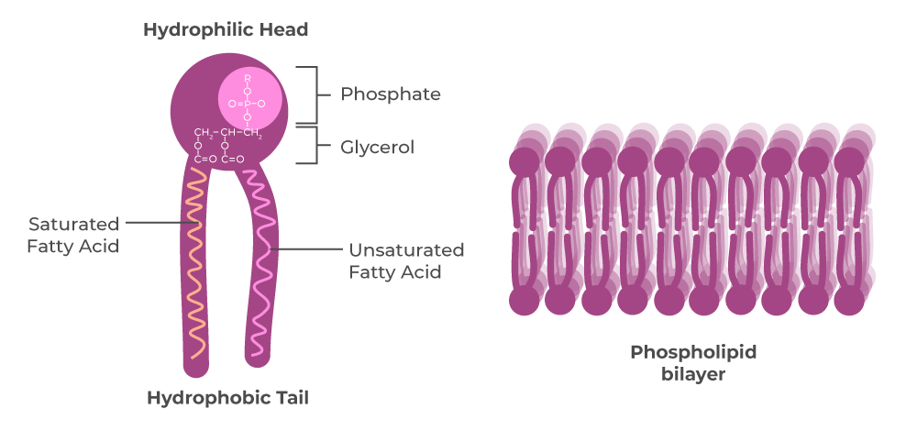

**Properties of Lipids**

They are organic compounds formed of fats and oils. Lipids produce high energy and perform different functions within a living organism, such as:

* Lipids stored in kidney.
* Lipids are generally hydrophobic, meaning they repel water and do not dissolve in it.
* Lipids are formed from hydrocarbon chains, and they are heterogeneous in nature.
* Fats and oils, in the form of triglycerides, are efficient energy storage molecules, providing a concentrated source of energy when broken down.
* Phospholipids are essential components of cell membranes, forming the lipid bilayer that defines cellular boundaries. They help in the selective permeability of a cell membrane.
* Lipids like cholesterol and steroid hormones consists of four-ring structure and function in membrane fluidity and cellular signaling.
* Lipids provide essential fatty acids that the body cannot produce on its own and allow the absorption of fat-soluble [vitamins](https://www.geeksforgeeks.org/vitamins/amp/).

**Structure of the Lipids**

Lipids are made up of two molecules, glycerol, and fatty acids. The structure of the lipid is as follows:

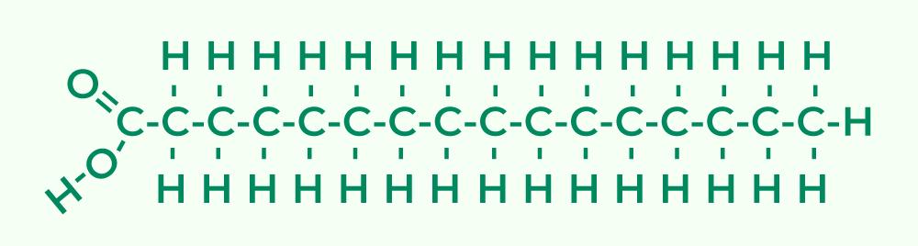

* Fatty acids are a type of lipids that consists of long hydrocarbon chains with a carboxyl group (COOH) at one end.
* In lipids, such as triglycerides, the glycerol molecule function as a backbone. Glycerol molecule consists of three carbon atoms with a hydroxyl group attached to them.
* Glycerol are linked to the fatty acid through ester bonds, that forms triglycerides.
* The hydrocarbon chains of fatty acids are hydrophobic, that is repelling water.
* In lipids like phospholipids, a hydrophilic phosphate group is attached to the glycerol, while the fatty acid chains remain hydrophobic, resulting in an **amphipathic molecule**.

**Function of Lipids**

Functions of lipids are mentioned below:

* Lipids, like adipose tissue, act as insulators and help to maintain body temperature by reducing heat loss.
* Lipids, especially triglycerides, act as energy storage in organisms, providing a reserve of metabolic fuel.
* Phospholipids form the lipid bilayers of cell membranes and regulate the passage of molecules in and out of cells.
* Protecting the plant leaves from direct heat and drying.
* Steroid hormones, derived from cholesterol, play vital roles in regulating various physiological processes, including metabolism, growth, and reproduction.
* It acts as the structural component of the body and also acts as the hydrophobic barrier.
* In plants, lipids can be stored as oils in seeds, providing a source of energy for germination and early growth.
* Lipids form waterproofing structures, such as the waxy cuticle on plant leaves or the oil on the feathers of water birds.
* It provides color to many fruits and vegetables with the presence of carotenoid pigment.

**Classification of Lipids**

Broadly, lipids are classified based on their chemical reactivity and the nature of their constituent molecules into two groups as follows:

1. Saponifiable Lipids
2. Nonsaponifable Lipids

**Nonsaponifiable Lipids**

* These lipids cannot be hydrolyzed or saponified using alkaline hydrolysis.
* They are often complex and structurally diverse.
* Examples of nonsaponifiable lipids include cholesterol (a steroid) and carotenoids (found in pigments like beta-carotene).

**Saponifable Lipids**

* Saponifiable lipids can be hydrolyzed or saponified using alkaline hydrolysis.
* They consist of fatty acids and other components that can be broken down into simpler compounds.
* The most common saponifiable lipids are triglycerides (fats and oils), which consist of glycerol and fatty acids esterified together.
* When saponified, these lipids break down into glycerol and fatty acids.
* Saponifiable are further divided into Polar and non-Polar lipids.

**Polar Lipids:**Polar lipids are also known as amphipathic lipids because they have both hydrophilic (water-attracting) and hydrophobic (water-repellent) regions within their molecular structure. Examples of polar lipids include phospholipids and glycolipids.

**Non- Polar Lipids:**Non-polar lipids are hydrophobic and do not have a significant hydrophilic component in their structure. They are primarily involved in energy storage and insulation. For example, Triglycerides (fats and oils).

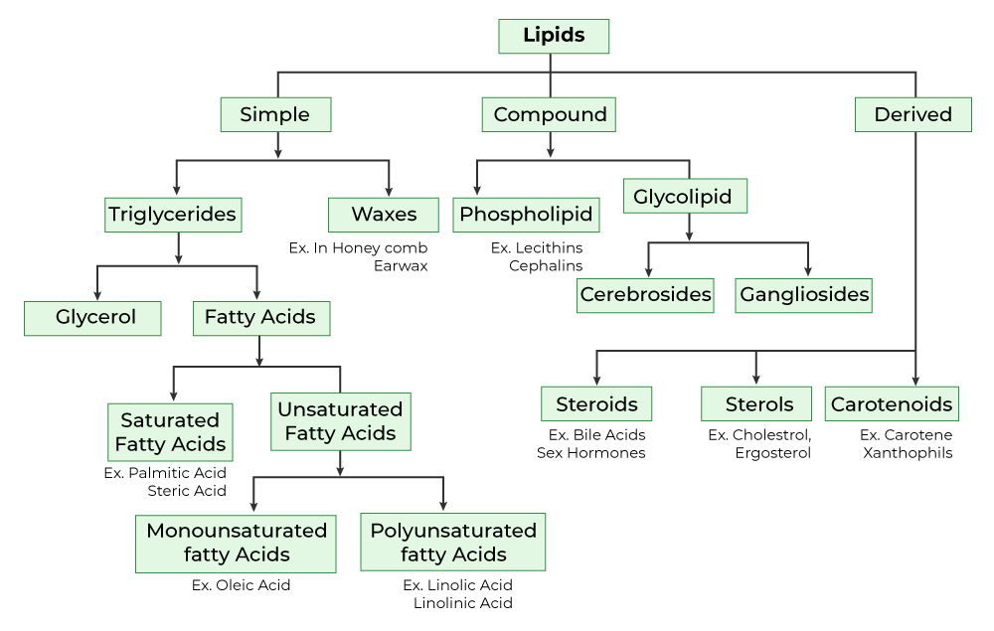

**Types of Lipids**

Lipids are mainly classified into three types. They are simple, complex, and derived lipids.

* **Simple Lipids**: Simple lipids are triglycerides, esters of fatty acids, and wax esters. The hydrolysis of these lipids gives glycerol and fatty acids.
* **Complex Lipids:** Complex or compound lipids are the esters of fatty acids with groups along with alcohol and fatty acids. Examples are Phospholipids and Glycolipids.
* **Derived lipids:** Derived lipids are the hydrolyzed compounds of simple and complex lipids. Examples are fatty acids, steroids, fatty aldehydes, ketone bodies, lipid-soluble vitamins, and hormones.

**Simple Lipids**

Simple lipids are triglycerides, esters of fatty acids, and wax esters. The hydrolysis of these lipids gives glycerol and fatty acids. Simple lipids are classified into Triglycerides and Waxes.

1. **Fats**: Fatty acids join with glycerol via ester bonds.
2. **Waxes:**Fatty acid jig with a large molecular weight monohydric alcohol with an ester bond.

**Triglycerides**

* Triglycerides are the most common type of simple lipids.
* They consist of glycerol molecules linked to three fatty acid chains through ester bonds.
* Triglycerides are found in adipose tissue (body fat) and serve as a long-term energy reserve.
* They are the constituents of fats and oils. Lipids that are solid at room temperature are fats, and lipids that are liquid at room temperature are oils.

**Glycerol**

It is a colorless, odorless, viscous liquid that is sweet-tasting and non-toxic. The glycerol backbone is found in those lipids known as glycerides. It is a simple polyol compound.

**Complex Lipids**

Complex lipids are a type of lipids that have more complex structures compared to simple lipids (triglycerides and waxes). They contain additional molecules, such as phosphates, carbohydrates, [proteins](https://www.geeksforgeeks.org/protein/amp/), fatty acids and glycerol. Complex lipids are involved in various biological functions, including cell structure, energy storage, and cell signaling. Examples are Phospholipids and glycolipids.

**Phospholipids**

Phospholipids are constituents of cellular membranes. An ester is formed when a hydroxyl reacts with a carboxylic acid and loses H2O. Phospholipids, also known as phosphatides, are classes of lipids whose molecule has a hydrophilic head and two hydrophobic tails. A head containing a phosphate group and tails derived from fatty acids joined by a glycerol molecule. They serve as emulsifiers.

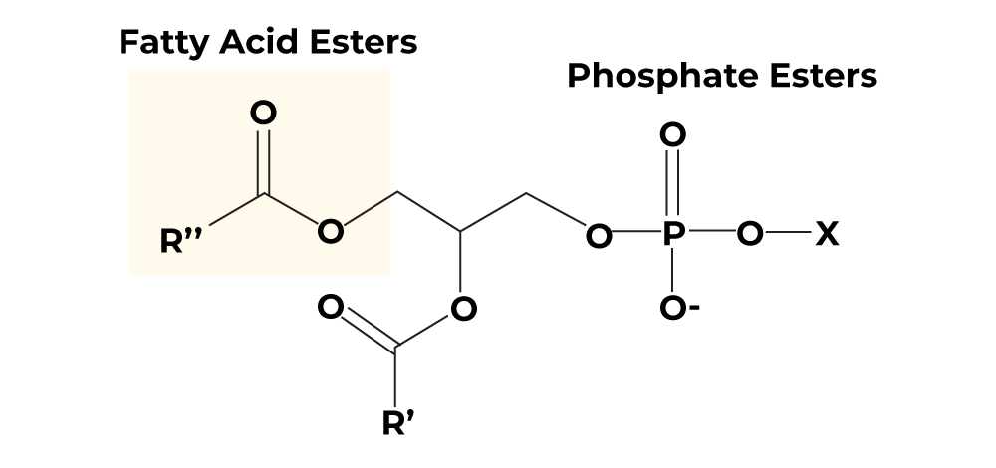

There are two types of phospholipids:

* **Glycerophospholipids:**Glycerophospholipids are the class of phospholipids containing glycerol as alcohol, two fatty acids, and phosphate. It is the most abundant lipid in the cell membrane.
* **Sphingophospholipids:**Sphingophospholipids are the class of phospholipids containing sphingosine as alcohol. It produces ceramide by an amide linkage to a fatty acid. Ceramide is an important component of skin. It acts as a second messenger to regulate **programmed cell death**.

**Glycolipid**

It is a structural lipid, an essential part of the cell membrane. They are lipids with a carbohydrate attached by a glycosidic bond. They act as receptors at the surface of the red blood cell. It helps in the determination of an individual [blood](https://www.geeksforgeeks.org/blood-components-functions-groups-and-disorders/amp/)group. It has an important role in maintaining of the stability of the cell membrane. It kills pathogens to help the [immune system](https://www.geeksforgeeks.org/immune-system/amp/) of the body. Cerebrosides and Gangliosides are the two types of Glycolipids.

**Precursor Lipids**

Precursor lipids are the building blocks from which other lipid molecules are synthesized or derived. They serve as starting points for the biosynthesis of more complex lipids. Some examples are- Fatty acids, Glycerol, and alcohol.

**Fatty Lipids**

Fatty acids are carboxylic acids; they are long chains of hydrocarbons with a carboxylic group at the end. Fatty acids are an important component of lipids, they are the building blocks of fat in the body. There are two types of fatty acids, saturated fatty acids and unsaturated fatty acids.

**Saturated Fatty Acids**

It consists of single C-C single bonds. These molecules fit closely together in a regular pattern and have strong attractions between fatty acid chains. These fatty acids have high melting points, which makes them solid at room temperature. Examples of saturated fatty acids are palmitic acid and stearic acid.

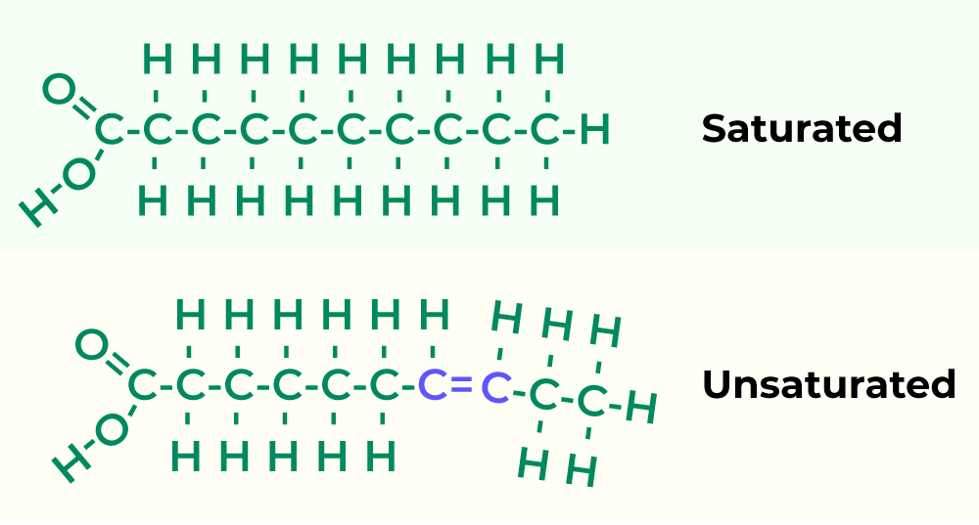

**Unsaturated Fatty Acids**

Unsaturated fatty acids are fatty acids that consist of one or more C=C double bonds. An unsaturated fatty acid is divided into two types.

1. **Mono polyunsaturated fatty acids:** Example: oleic acid.
2. **Polyunsaturated fatty acids:** Example: linoleic acid.

**Role of Fats**

Fats play an essential role in the body, including:

* Fats help our body by absorbing and transporting important fat-soluble vitamins.
* They are an important source of essential fatty acids.
* They insulate and protect our vital body organs.
* Fats produce energy in the form of carbohydrates.
* Fats are the structural component of cells.
* They help the body produce and regulate hormones.
* Fats support cell growth.
* They maintain our core temperature.
* Maintains blood pressure and cholesterol.

**Derived Lipids**

Derived lipids are the hydrolyzed compounds of simple and complex lipids. Examples are fatty acids, steroids, fatty aldehydes, ketone bodies, lipid-soluble vitamins, and hormones.

**Steroids**

Steroids are found in the cell membrane and have fused ring structures. Many steroids have -OH functional groups, they are also hydrophobic and insoluble in water. All the steroids have 4 linked carbon rings and most of them have a short tail. Steroids also act as hormones in the body.

**Sterols**

Sterols are solid steroid alcohols that are widely present in plants and animals such as cholesterol and ergosterol. They are the subgroup of steroids, which naturally occur in most [eukaryotes](https://www.geeksforgeeks.org/eukaryotic-cells-definition-characteristics-structure-functions/amp/). They are found in animal products. They are used to make bile for digestion in the body. Sterols can have greater than half of the membrane lipid content in cells and they are known to alter membrane structure and fluidity.

**Carotenoids**

Carotenoids are lipid-soluble compounds. They are pigments that are mainly responsible for the yellow and red colors of plant and animal products. Carotenoids consist of carotenes and xanthophylls. A class of hydrocarbons is carotenes and its oxygenated derivatives are xanthophylls. They give color to many fruits and vegetables. They have antioxidant and anti-inflammatory properties for humans. Carotenoids are important for the health of the human eye.

**Examples of Lipids**

There are so many examples of lipids. Such as Ghee, Butter, Oil, Cheese, Cholesterol, waxes, etc. All these compounds have one thing in common i.e., they are insoluble in water and are soluble in organic solvents. Examples of lipids are as follows:

* **Triglycerides:**Found in fats and oils, these store energy in cells.
* **Phospholipids:** Key components of cell membranes, forming lipid bilayers. Both TAG and phosphoacylglycerol structures are almost the same just, phosphoacylglycerol-OH and phosphoric acid are attached with an ester bond and form the phosphatidic acid.
* **Steroids:** Include cholesterol, a membrane component, and steroid hormones.
* **Waxes:** Provide waterproofing in plants, animals, and microorganisms. Waxes are usually saturated with long-chain monohydric alcohols. They are the simple esters of fatty acids. Here are some examples:
  + **Beeswax:**Beeswax includes fatty acids and some free alcohol.
  + **Carnauba wax:** It is a hard wax used on cars and boats.
  + **Spermaceti**: it consists of cetyl palmitate. Used for pharmaceuticals.
* **Glycolipids:** Contain carbohydrates and are important in cell recognition.
* **Sphingolipids:** A diverse group of lipids involved in signaling and structure.
* **Lipoproteins:**Complexes of lipids and proteins, transport lipids in the bloodstream.
* **Eicosanoids:**Signaling molecules derived from fatty acids, regulate inflammation.
* **Isoprenoids:** Include vitamins (e.g., vitamin A) and carotenoids, with various functions